**DAILY ONLINE ACTIVITIES SUMMARY**

|  |  |  |  |  |  |  |  |  |
| --- | --- | --- | --- | --- | --- | --- | --- | --- |
| **Date:** | **14-06-2020** | | | | | **Name:** | **Anix Jugal D’Cunha** | |
| **Sem & Sec** | **8 sem , A sec** | | | | | **USN:** | **4AL16CS013** | |
| **Online Test Summary** | | | | | | | | |
| **Subject** | | **--** | | | | | | |
| **Max. Marks** | | **--** | | **Score** | | | **--** | |
| **Certification Course Summary** | | | | | | | | |
| **Course** | **Java Programming Fundamentals** | | | | | | | |
| **Certificate Provider** | | | **Udemy** | | **Duration** | | | 1.5 Hours |
| **Coding Challenges** | | | | | | | | |
| **Problem Statement:** Java program to calculate Permutation and Combination of 2 numbers | | | | | | | | |
| **Status: Competed** | | | | | | | | |
| **Uploaded the report in Github** | | | | | **yes** | | | |
| **If yes Repository name** | | | | | **alvas-education-foundation/dcunhaanixjugal** | | | |
| **Uploaded the report in slack** | | | | | **yes** | | | |

Online Test Details: (Attach the snapshot and briefly write the report for the same)

Not Conducted

Certification Course Details: (Attach the snapshot and briefly write the report for the same)

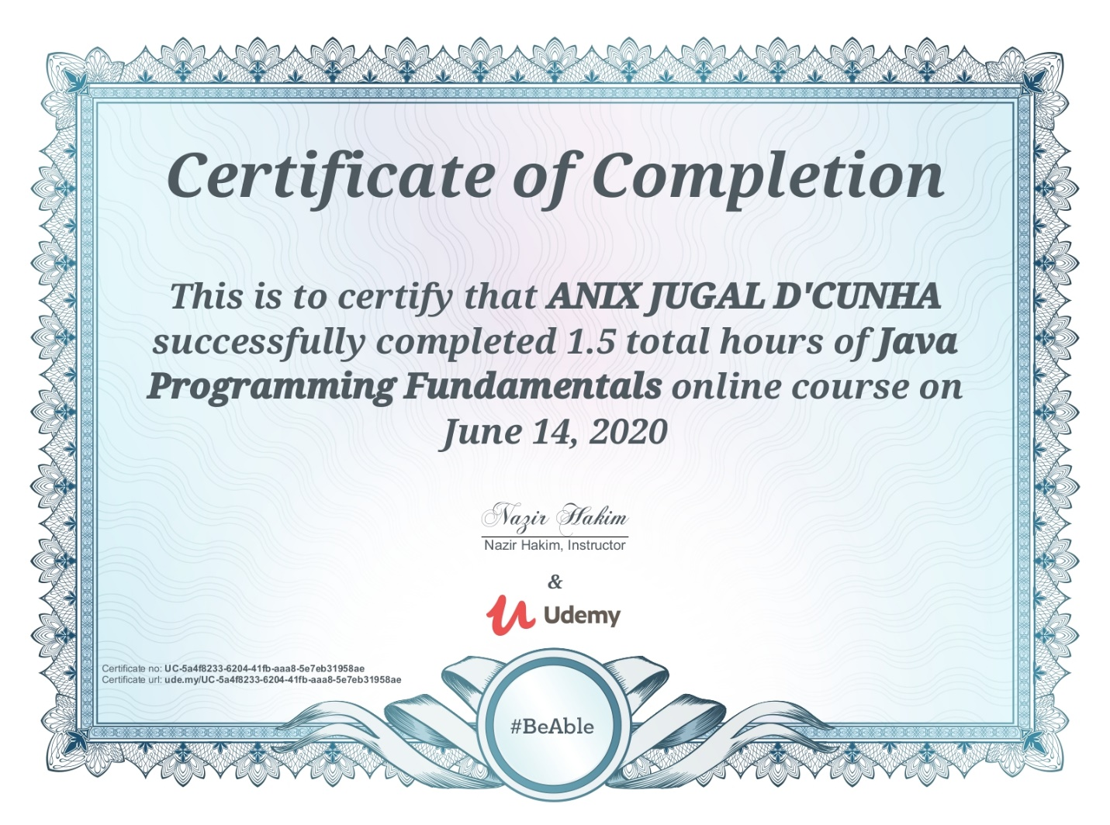

Coding Challenges Details: (Attach the snapshot and briefly write the report for the same)

Program-> Java program to calculate Permutation and Combination of 2 numbers

|  |
| --- |
|  |
|  | import java.util.Scanner; |
|  | public class nprandncr { |
|  | public static int fact(int num) |
|  | { |
|  | int fact=1, i; |
|  | for(i=1; i<=num; i++) |
|  | { |
|  | fact = fact*i; |
|  | } |
|  | return fact; |
|  | } |
|  | public static void main(String args[]){ |
|  | int n, r; |
|  | Scanner scan = new Scanner(System.in); |
|  | System.out.print("Enter Value of n : "); |
|  | n = scan.nextInt(); |
|  | System.out.print("Enter Value of r : "); |
|  | r = scan.nextInt(); |
|  | System.out.print("NCR = " +(fact(n)/(fact(n-r)*fact(r)))); |
|  | System.out.print("nNPR = " +(fact(n)/(fact(n-r)))); |
|  | }  } |